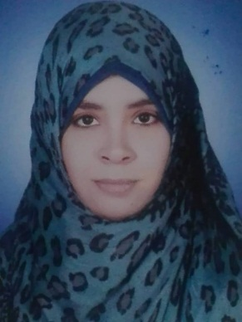
Curriculum Vitae
Personal Data:
• Name: Entsar Hsanen Mohamed
• Title: M.Sc. Degree in Chest Diseases
• Current Position: Assistant lecturer of pulmonary medicine, Assuit University Hospitals, Egypt .
• Gender: Female
• Marital status: Single
• Nationality: Egyptian
• Birth date: May 21th. 1989
• Place of birth: Qena, Egypt
• Affiliation: Chest Department, Assiut University Hospitals, Assiut.
• E-mail:
dr.entsar_hsanen@yahoo.com
entsar.hsanen@aun.edu.eg

- Cellular phone: +201019968106
• Fax: +20882333327 (Hospital Fax)
• Languages: English and Arabic.
• Major specialty: Internal Medicine
• Minor specialty: Pulmonary medicine
• Postal Address: Assiut University Hospital, Main building, Department of Chest Diseases, 7th floor. Postal code: 71515
Qualifications and degrees:
• General certificate of secondary education in 2005.
• MB.B.Ch, Bachelor degree of medicine and surgery, faculty of medicine, Assiut University, 2012 (Excellent).
• M.Sc. of Chest diseases, Assiut University, Egypt in May 2018 (very good).
Positions held:
a) Current: Assistant lecturer in department of chest diseases and tuberculosis, Assiut University Hospitals, Egypt
b) Past:
• House officer for one year in Assuit University hospitals from 1/3/2013 till 28/2/2014.
• Resident doctor of pulmonary medicine in department of chest diseases and tuberculosis, Assiut University hospitals from 1/3/2014 till 1/9/2016.
• Demonstrator of pulmonary medicine in department of chest diseases and tuberculosis, Assiut University hospitals from 1/9/2016 till 5/3/2018

Scientific activities:
• Supervision of the scientific and clinical performance of junior residents and house officers.
• Attending and participating in organizing national scientific meetings and conferences regularly in Egypt.
• Master research entitled (completed): Evaluation of Short-term Versus Conventional Glucocorticoids Therapy in Acute Exacerbationsof Chronic Obstructive Pulmonary Disease
Skills:
1- Clinical evaluation and management of respiratory diseases
2- Thoracic ultrasonography
3- Thoracic interventions:
- Pleural aspiration
- Pleural biopsy
- US guided tru-cut biopsy

4- Interpretation of arterial blood gases
5- Interpretation of pulmonary function tests: Spirometry, Lung volumes (Body plethysmography), diffusion and impulse oscillometry.
6- Experience in critical care medicine from in respiratory intensive care unit (RICU) of Assiut University Hospital.
7- Experience in sleep medicine. Sleep lab of chest department- Assiut University
Community activities:
Participation in many medical convoys to remote, desert and poor areas (e.g. New Valley , Manfalot)

